MODELING OF A VEHICLE FRONT BUMPER

OBJECTIVES

The project focused on designing a front safety bumper that absorb energy during collisions and maintained its structural integrity under impact conditions. Others were:
- To develop the bumper geometry for optimal energy dissipation during frontal impacts.
- To conduct finite element analysis to evaluate its structural performance and identify the best material.

ENGINEERING ACTIVITIES

I narrowed down my options to three main candidates: cast steel, aluminum wrought alloy & iron (gray cast). I chose cast steel because it offered high toughness and ductility, which enhanced crash energy absorption under static loading conditions. I included aluminum wrought alloy due to its lightweight properties and corrosion resistance, which helped to reduce vehicle mass, safeguarding against structural failure. I selected iron (gray cast) for its excellent compressive strength and cost-effectiveness, as documented in engineering references.
Table 1: Engineering Properties of the Material
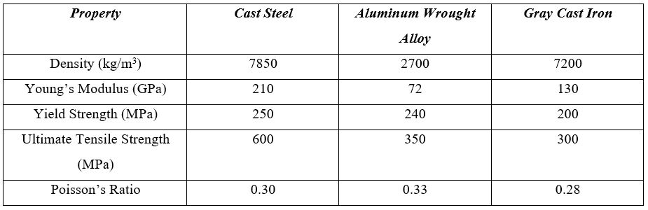
In the next stage, I proceeded to the designing phase and opened SolidWorks. I started a new design section and selected the plane as a front for the base reference to sketch the bumper design. I sketched a centerline then a circle of diameter 80 mm. I used the feature of extruding to create the main pipe 1000 mm long. I then switched to the Top Plane and marked three support locations at 250 mm, 500 mm, and 750 mm from the left end. I created sketched for the support tubes using 60 mm diameter circles and extruded them 120 mm toward the main pipe. I applied concentric mates by establishing coincident surfaces and used Cut-Extrude with small gaps where necessary. I designed square flanges measuring 100 x 100 mm for each support and extruded them 6 mm thick. I created four 10 mm mounting holes in each flange using the Hole Wizard, positioning them on a 70 mm bolt circle. I added 2 mm fillets to all edges to improve manufacturability. I used circular pattern to duplicate the support assemblies along the length of the pipe. I generated a shaded rendering isometric view with complete and precise dimensions.
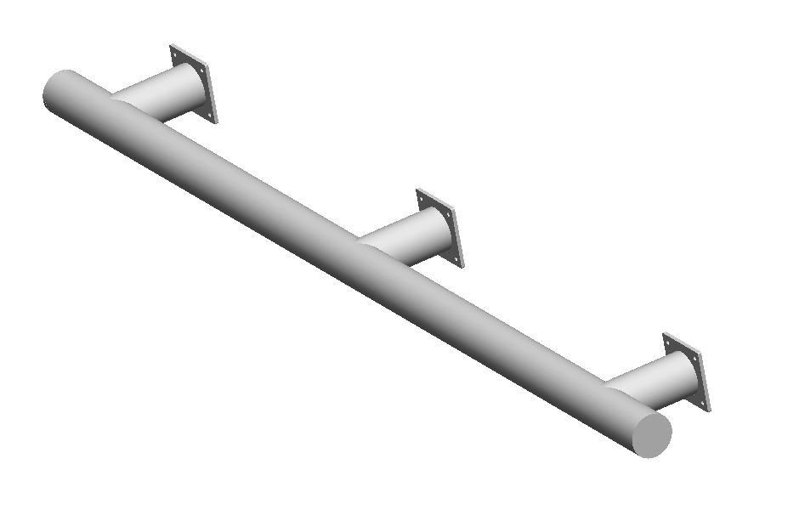
Figure 2: Safety Front Bumper in Third-Dimensional View

I built the finite element model in ANSYS after finishing the 3D modeling work. At first, I exported the model in IGES format and imported into ANSYS. I initially created an automatic meshing and then applied 5 mm element size with body sizing control to get consistent meshing across the pipe and support flanges, thereby providing good accuracy without making the computation too heavy. I fixed all the three flange plates completely by locking their movement and rotation which simulated how they be bolted in real scenario. I applied a 50,000 N force on the pipe’s outer surface to replicate the crash force, the structure experienced in real world.
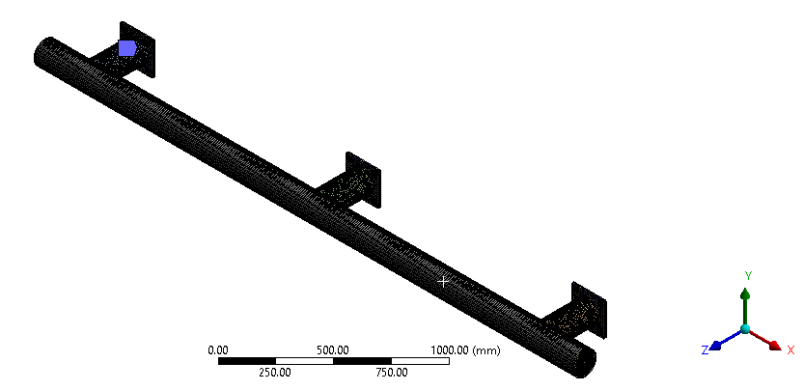
Figure 3: Safety Frame in meshing view
I evaluated the simulation results by comparing the deformation, stress and strain patterns of the trio materials. I detected that cast steel established the slightest distortion and strain among all three materials, indicating superior stiffness & excellent resistance to external loading which made it highly suitable for structural components requiring strength and dimensional stability. I found that gray cast iron sustained stress levels comparable to cast steel but exhibited higher deformation, suggesting reduced rigidity and decreased reliability under repeated or dynamic loading conditions. I realized that wrought aluminum alloy showed the largest deformation and strain values, reflecting its lower stiffness and limited applicability for high-load structural applications. I acknowledged that while aluminum showed benefits like reduced weight and corrosion resistance, it was not the best option for this application. Therefore, I concluded by selecting the cast steel as the best and appropriate material, delivering an optimal balance of strength, rigidity and durability.
Table 2: Comparison of Simulation Results for Different Material Based on Structural Performance
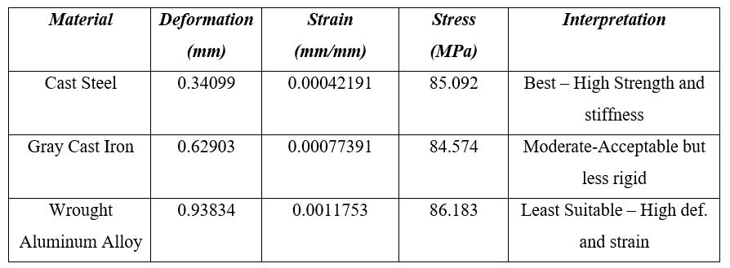
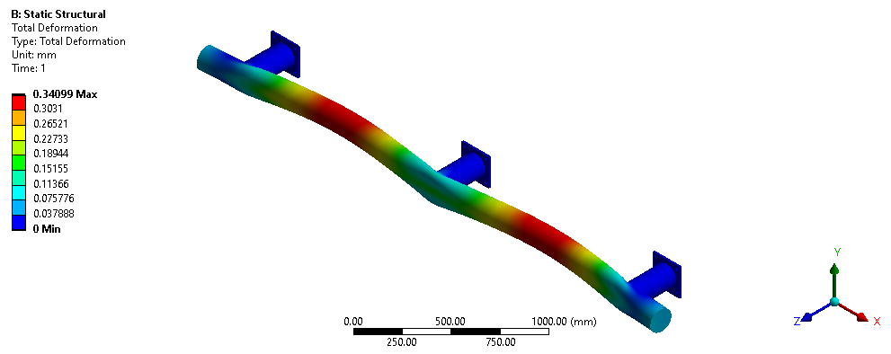
Figure 4: Def. Contour for steel (cast)
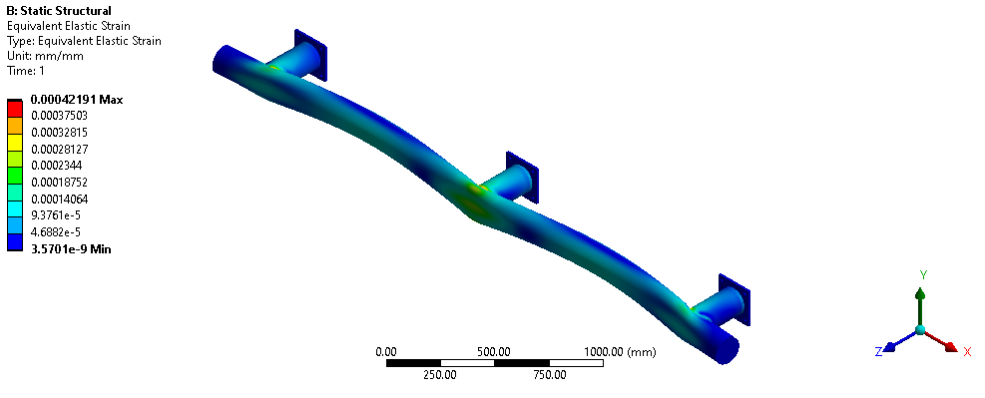
Figure 5: Strain Contour for steel (cast)
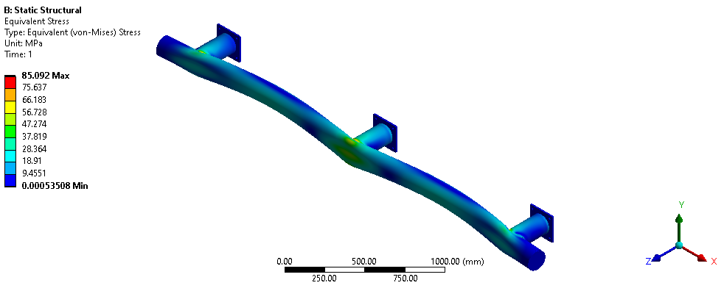
Figure 6: Stress response in steel (cast)
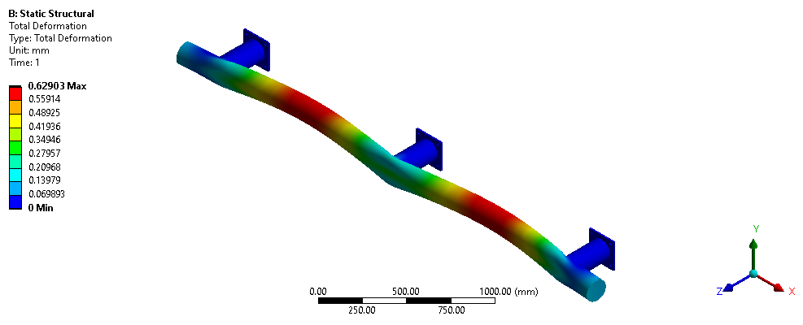
Figure 7: Def. observed in gray iron (cast)
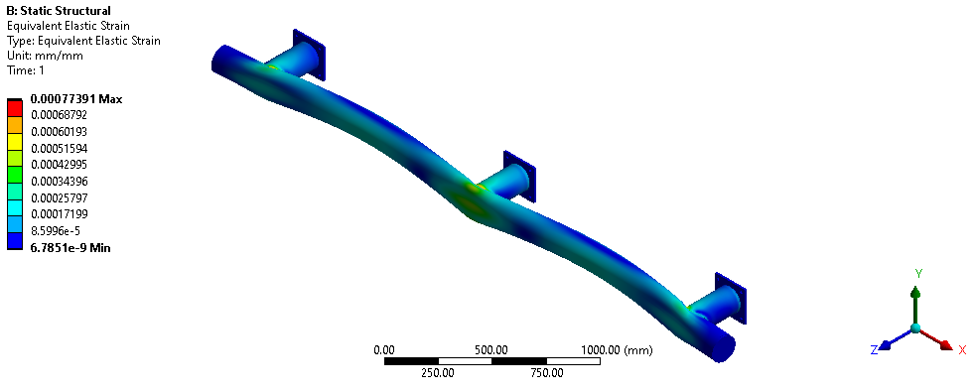
Figure 8: Strain response in gray iron (cast)
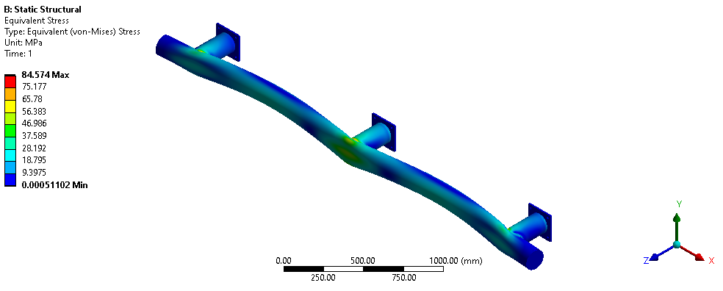
Figure 9: Stress distribution in gray iron (cast)
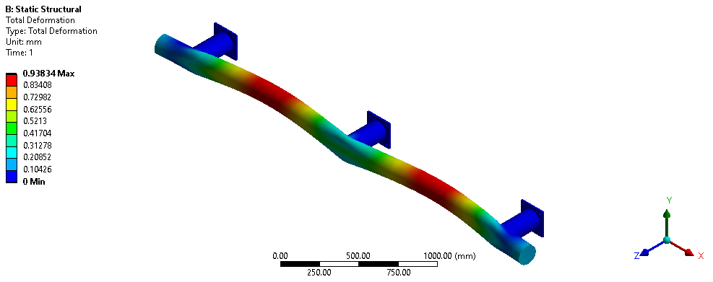
Figure 10: Wrought Aluminum Alloy under Deformation
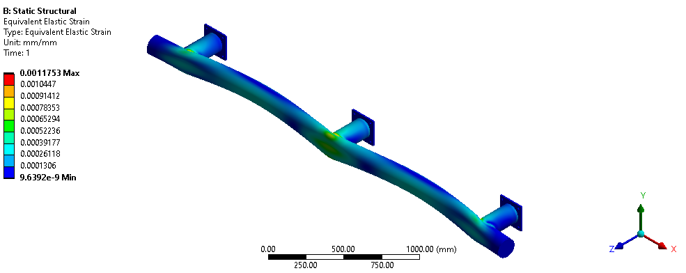
Figure 11: Wrought Aluminum Alloy Strain Analysis
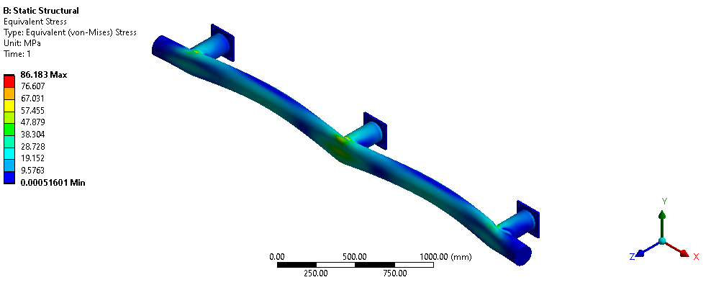
Figure 12: Wrought Aluminum Alloy Stress Behavior

TECHNICAL PROBLEM AND SOLUTION

I confronted the first problem during the bumper model meshing process, where automatic meshing created irregular elements at the curved flange intersections. I found this meshing issue stemmed from complex geometry transitions in those areas, which compromised the accuracy of stress distribution calculations. I observed the irregular mesh elements reduced the reliability of both deformation and strain analysis results. To solve this, I implemented body sizing with a uniform 5 mm element size which refined the mesh quality and provided consistent stress evaluation throughout the model. Another challenge I encountered when calculating the applied crash force on the simulation. I initially applied the peak force directly without accounting for realistic impact loading conditions. I recognized that this assumption led to overestimated stress values and unrealistic deformation results. To address this issue, I averaged the impact force rather than using the peak value alone and validated my approach through velocity calculations which confirmed the improved method and significantly upgraded the accuracy of the simulation outcomes.

SUMMARY
The project aim was to design and analyze a front safety bumper that effectively absorb collision energy while keeping the structure intact and passengers safe. A thorough literature survey was conducted to examine existing bumper designs to know the process of absorbing energy, and performance of different materials. Three materials were selected: iron (gray cast), cast steel & wrought alloy of aluminum by looking at their strength, capability, manufacturability and cost effectiveness. A detailed 3D bumper model including main pipes, support pipes, flanges, fillets and mounting holes were modeled in SolidWorks and exported in IGES format to import it in ANSYS to run the simulation. Before running, the mesh was created of the model and applied body sizing with an element of 5 mm. The boundary conditions such as fixed support at the flanges and crashing force of 50000N was applied and ran the simulation. The outcomes of the simulation suggested that cast steel provided the best combination of strength, durability and energy absorption for the front safety bumper.

